RESULTS

  - Country of origin and status of neuro-oncologists
The sample isconsisting of 35 neurosurgeons, radiotherapists, neuro-oncologists, neuro-nurses in oncology, pathologists and neurosurgery trainees across West Africa.
The sample was composed of 25.71% Beninese, 17.14% Nigeriens, 14.29% Ivorians, 14.29% Malians and 11.43% Ghanaians. Four other countries (Burkina Faso, Nigeria, Senegal and Togo) represent approximately 25% of the sample studied. Similarly, 45.71% of the respondents were neurosurgeons and 51.43% were neuro-oncology residents.
Tableau I: Country of origin and status of the neuro-oncologists surveyed
 | Staff (n) | Percentage (%)
Country
Benign | 9 | 25.71
Niger | 6 | 17.14
Ivory Coast | 5 | 14.29
Mali | 5 | 14.29
Ghana | 4 | 11.43
Burkina Faso | 2 | 5.71
Nigeria | 2 | 5.71
Senegal | 1 | 2.86
Togo | 1 | 2.86
Status
Neurosurgeons | 16 | 45.71
Anatomopathologists | 1 | 2.86
Resident | 18 | 51.43

  - Professional characteristics of neuro-oncologists
More than half (57.14%) of the specialists surveyed had less than 3 years of experience in neuro-oncology. The number of cases they consult is relatively low, with an annual average of less than 100 cases according to 74.29% of specialists. In addition, it is noted that 88.57% of them perform excisional surgeries. Generally, in 90.32% of cases, the number of excisions performed per year remains below 100 patients. However, the cAwake excision surgery is a rarely performed procedure, with approximately one-third (34.29%) of specialists involved. 91.67% of those who perform it do not exceed 25 patients per year. As for stereotaxic biopsy, the practice also remains low, with only 28.57% of specialists involved. A low practice rate that can be explained by the small number of cases (less than 50 per year) that are indicated. Furthermore, when we look at paramedical examinations and procedures, we note that 82.86% of specialists perform chemotherapy, 80% anatomopathological examinations, 51.43% immunohistochemistry examinations and 14.29% biomolecular examinations. Similarly, 74.29% of specialists, or three-quarters of them, perform clinical trial protocols.
Tableau II: Professional characteristics of the neuro-oncologists surveyed
 | Staff (n) | Percentage (%)
Years of experience in neuro-oncology (years)
< 3 | 20 | 57.14
[3-6[ | 8 | 22.86
6 and over | 7 | 20.00
Average number of annual consultations
< 100 | 26 | 74.29
[100-200[ | 6 | 17.14
[200-300[ | 1 | 2.86
300 and over | 2 | 5.71
Neuro-oncology interventions, excision surgery
Yes | 31 | 88.57
No | 4 | 11.43
Average number of annual cases
< 100 | 28 | 90.32
100 and over | 3 | 9.68
Awake excision surgery
Yes | 12 | 34.29
No | 23 | 65.71
Average number of annual cases
< 25 | 11 | 91.67
25 and over | 1 | 8.33
Stereotaxic biopsy
Yes | 10 | 28.57
No | 25 | 71.43
Average number of annual cases
< 50 | 10 | 100.0
Examinations and acts
Chemotherapy | 29 | 82.86
Anatomopathological examinations | 28 | 80.00
Clinical trial protocol | 26 | 74.29
Immunohistochemistry tests | 18 | 51.43
Biomolecular examinations | 5 | 14.29

  - Resources for neuro-oncologists in the ECOWAS region
By analyzing data on the number of specialists by country, we note that all countries suffer - at various levels - from a glaring lack of neuro-oncologists, but especially from specialized health centers. With 14 hospitals, Nigeria is the country with the largest number of hospitals offering neuro-oncology services in the sub-region. However, we note that only nine (09) of these hospitals have an operational neuro-oncology service, representing an operationalization rate of 64.29%. With 3 neuro-oncology services, Senegal is the second country with the largest number of operational centers. Ghana and Ivory Coast follow with 2 operational centers.

Figure 1:Distribution of neuro-oncology centers in ECOWAS countries
Regarding the number of specialists, Nigeria stands out with more than 50 neurosurgeons, followed by Senegal and Ghana with a number of between 35 and 40 neurosurgeons. Togo is the least endowed country with less than 10 neurosurgeons. At the same time, when comparing the population ratios of neurosurgeons by country, we note that Nigeria suffers from the greatest deficit of specialists, reflecting a deficit of specialized services and neuro-oncologists, despite the country having the largest number of neuro-oncology services in the West African sub-region. Indeed, Nigeria has a ratio of 1 neurosurgeon per 1.6 million inhabitants compared to 1 per 700 thousand inhabitants in Senegal, which has the best ratio in the sub-region.
As for the other specialties, we note that
Most countries in the subregion have fewer than five specialists in each of the following specialties: neuroradiologists, pathologists, medical oncologists, and neuro-oncologist nurses. Only Nigeria, Senegal, Ghana, and Burkina Faso each have more than 10 radiotherapists. Regarding neuro-oncologists, Nigeria and Ghana each have more than 10 specialists. As for neuro-oncologist nurses, no country in the subregion has more than five specialists.
Furthermore, as far as pathologists are concerned, only Nigeria stands out with 6 to 10 specialists.
Generally, the limited number of neuro-oncologists available is concentrated primarily in neurosurgery. These data highlight the major challenge of specialist shortages facing West African countries. This represents a real public health issue, particularly for the subregion due to its rapidly growing population.

Figure 1:Spectral distribution of specialist staff by discipline in the ECOWAS region

  - Multidisciplinary consultation framework in neuro-oncology
    - Situation of the existence of consultation frameworks
Overall, 34.29% (12/35) of the surveyed specialists stated that they have a scientific framework for multidisciplinary consultation in neuro-oncology. However, depending on the country, disparities appear, revealing differences in access to multidisciplinary exchanges in neuro-oncology. Indeed, we note that countries such as Côte d'Ivoire, Ghana and Senegal are well ahead on the subject with the existence of a consultation framework allowing systematic exchanges between specialists. These three countries are exceptional in having a consultation framework in neuro-oncology allowing 100% of professionals and specialists to carry out their activities effectively. The frequency of meetings, from one country to another, varies from weekly to monthly meetings. In addition, we note that Nigeria and Mali are less equipped with respectively 50% and 20% of their specialists integrated into a multidisciplinary consultation system. Although these two countries have an operational framework for consultation, serious efforts still need to be made to improve the operability of multidisciplinary exchanges between neuro-oncology specialists.
On the other hand, four countries in the ECOWAS region do not have any framework for multidisciplinary consultation in neuro-oncology. These countries include Togo, Niger, Burkina Faso, and Benin.

Figure 2:Rate of knowledge among specialists of the existence of a multidisciplinary consultation framework in neuro-oncology

Figure 2:Spectral distribution of the existence of a multidisciplinary consultation framework in neuro-oncology in the ECOWAS region
    - Reasons associated with the non-existence of consultation frameworks
A closer look at the data reveals that the lack of functional multidisciplinary consultation frameworks is due to several dysfunctions inherent in the health systems of the various countries in the ECOWAS zone.
- Lack of specialists in each discipline
The primary reason for the lack of a multidisciplinary consultation network remains the lack of human resources. Indeed, in the four countries (Togo, Niger, Burkina Faso, and Benin) that do not have a multidisciplinary consultation framework in neuro-oncology, specialists believe that this is due to a lack of specialists. Burkina Faso and Togo are, moreover, the most affected by the lack of specialists in each discipline, compared to Benin and Niger.
At the same time, the shortage of specialists is not a significant problem in Nigeria, which highlights the influence of other factors that explain the inoperability of the neuro-oncology consultation framework in this country.

- The fluidity of collaborations between specialists: a cyclical factor
The few existing specialists experience difficulties collaborating in countries like Niger, and to a lesser extent Togo, Mali, and Benin. Indeed, the few specialists who exist have difficulty communicating with each other, which limits their ability to work effectively and collaboratively. While the lack of fluidity in collaboration between specialists from countries in the regional area is initially due to the lack of a structural framework for consultation, it should also be noted that the lack of exchanges between specialists in the same field or in complementary fields is due to a lack of personal will between the different specialists. This circumstantial factor explains in particular the fact that specialists from countries like Nigeria or Burkina Faso continue to communicate with each other, to network, particularly through social networks, despite the lack of a formal framework for consultation.
- Lack of vision and leadership: a structural factor
West African healthcare systems are particularly affected by policy failures and, above all, a lack of global vision. While each country has its own health policy, leaders struggle to agree on a regional health policy. This political and structural limitation particularly impacts the ability of neuro-oncologists to network and collaborate effectively with a view to synergizing action for better medical care. This also highlights the need for a regional multidisciplinary consultation framework or to expand and merge the functional frameworks of countries such as Côte d'Ivoire, Ghana, and Senegal. The impact will be all the more significant since the globalization of consultation frameworks would facilitate knowledge transfer between specialists from various countries, while improving their scientific productivity and their ability to network with international specialists. Moreover, 97.14% of the specialists surveyed agree with the introduction of a regional inter-university diploma for neuro-oncology specialties, in order to facilitate university exchanges and the recognition of skills at the regional level.
- An inoperative system: a structural factor
The spectral analysis indicates that two countries have an existing consultation framework, but it is ineffective, dysfunctional, or even rejected by professionals. Indeed, specialists in Nigeria and Mali decry the inadequacies of their multidisciplinary exchange framework. They cite shortcomings related to the quality of the exchange system, knowledge transfer, and exchange fluidity. In these countries, the consultation framework exists, but is unsuitable for the needs of neuro-oncology specialists, which hinders its adoption. Moreover, it should be noted that only 50% of Nigerian neuro-oncologists and 20% of Malian specialists used the consultation framework in their countries. Thus, a policy to create a regional framework for multidisciplinary consultation in neuro-oncology can be inspired by the functioning of SNOOSSA (Société de Neuro-Oncologie de l'Afrique Sub-Saharienne), which at the African level constitutes one of the main neuro-oncology networks even if it typically focuses on research. It turns out that 40% of the specialists surveyed have already participated in a SNOOSSA conference, which constitutes a significant basis for the establishment of a consultation framework inspired by the functioning of SNOOSSA. Also, it is important to specify that 94.29% of specialists are interested in the creation of a West African sub-regional collaboration network for neuro-oncology.

Figure 3:Factors associated with the lack of a multidisciplinary consultation framework in neuro-oncology in the ECOWAS region

APPENDICES

Annexes
In case of difficulties in manipulating the graphs present in the analysis report, we have indicated in the appendices, illustrated versions (non-modifiable) of these graphs, to facilitate manipulations, in particular in other software or text editors.
- Additional graphs

Figure: Existence of a multidisciplinary consultation framework in neuro-oncology in the ECOWAS region

- Image graphs
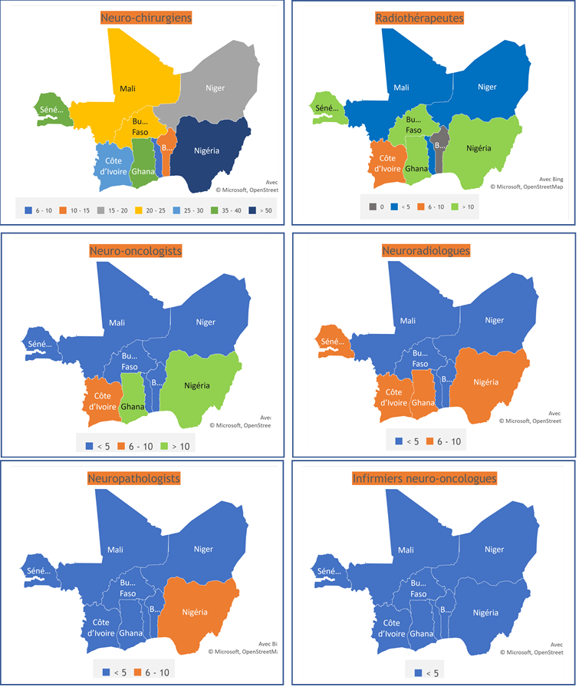
Figure 1:Spectral distribution of specialist staff by discipline in the ECOWAS region
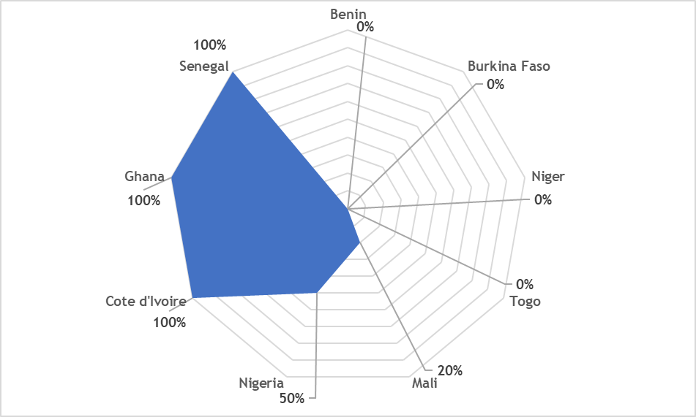
Figure 2:Distribution of specialists in the existence of a multidisciplinary consultation framework in neuro-oncology in the ECOWAS region

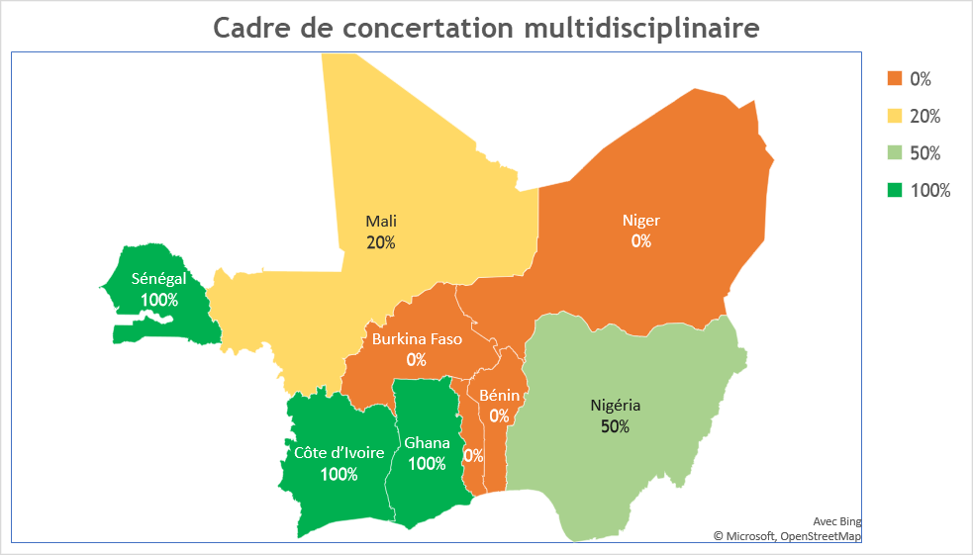
Figure 2: Spectral distribution of the existence of a multidisciplinary consultation framework in neuro-oncology in the ECOWAS region

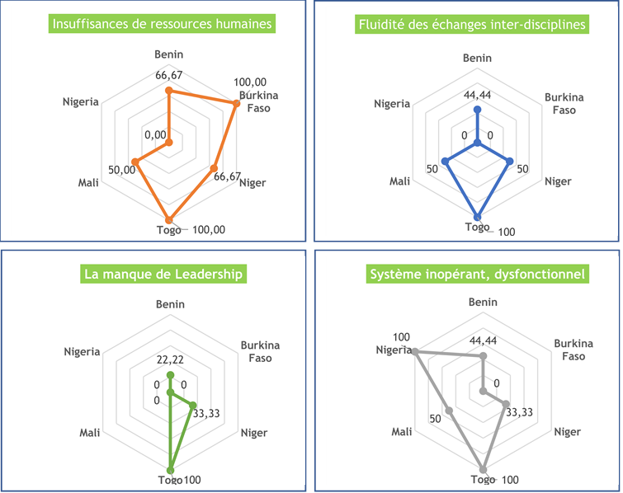
Figure 3: Factors associated with the lack of a multidisciplinary consultation framework in neuro-oncology in the ECOWAS region

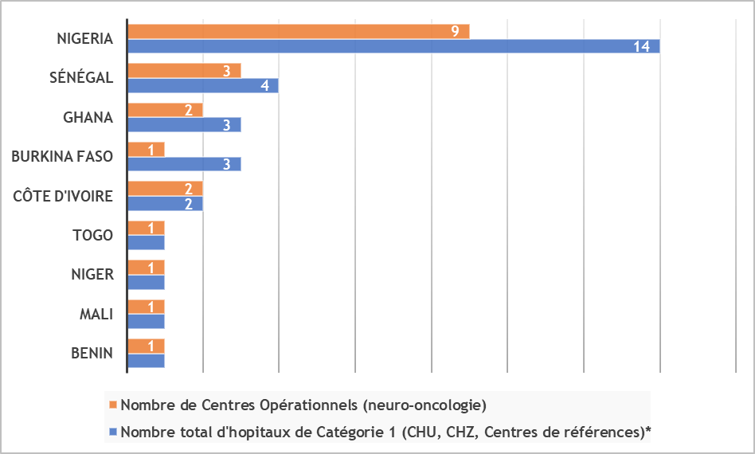
Figure 1:Distribution of neuro-oncology centers in ECOWAS countries

In the absence of official data available by country and for their specific health centers, we asked the study specialists about trends in the number of specialists available by country.

